**WSGG Model for a Mixture of $H_{2}O$, $CO_{2}$ and Soot**

**Line-by-line integration of the RTE**

Before we present the WSGG formulation, let us first review the Line-by-line integration of the radiative spectrum for model verification purposes. The variation of the spectral intensity is determined from

|  |  |
| --- | --- |
| $$\frac{dI_{λ}}{ds}=-κ_{λ}I_{λ}+ κ_{λ}I_{b,λ}$$ | (1) |

The mixture spectral absorption coefficient $κ_{λ}$ is obtained by superposition of the spectral absorption coefficients of $H_{2}O$, ${CO}_{2}$ and soot

|  |  |
| --- | --- |
| $$κ_{λ}=κ_{λ,w}+κ_{λ,c}+κ_{λ,s}$$ | (2) |

For $H_{2}O$ and ${CO}_{2}$, the local values of $κ_{λ,w}$ and $κ_{λ,c}$ for each wave number, temperature and partial pressure should be obtained by means of interpolation from a spectral database called HITEMP2010.

For soot, the value of $κ_{λ,s}$ is obtained from

|  |  |
| --- | --- |
| $$κ_{λ,s}=f_{v} β λ$$ | (3) |

Where $f_{v}$ is the soot volume fraction and $β$ is a fuel dependent quantity (=4.9 for propane, unknown for ethylene).

1. **WSGG model for a mixture of $CO_{2}$, $H_{2}O$ and soot with any partial pressures path length in the range 0.001-10 atm.m**

The integration of the spectral intensity in the WSGG framework is given by

|  |  |
| --- | --- |
| $$\frac{dI_{m,j}}{ds}=-κ_{m,j}I_{m,j}+ κ_{m,j }a_{m,j} I_{b}$$ | (4) |

where $j=1:J_{m}$, $J_{m}$ is the total number of gray gases representing the entire spectrum, and subscript m refers to the mixture.

In this superposition method, each of the species is represented by its own specific number of gray gases such that

|  |  |
| --- | --- |
| $$J_{w}=5 , J_{c}=5 , and J_{s}=2 or 3 or 4$$ | (5) |

where subscripts *w, c* and *s* refer to $H_{2}O, CO_{2}$ and soot, respectively.

The water vapor and carbon dioxide are described using 4 gray gases and one transparent gas such that the total number of bands is 5 for each species. Soot can be represented by either 2, 3 or 4 gray gases depending on the desired accuracy of the model. Note that 4 gray gases are preferred for soot since 2 and 3 gray gases show very large errors ( $\sim 150\%)$ in the total emittance at low soot volume fraction $\sim {10}^{-8}$ and low temperature $\sim 400K$. However, this error shrinks as the soot volume fraction and temperature increase (see Fig. 1 in appendix A).

The total number of bands that represent the entire spectrum of the mixture of $H_{2}O, CO_{2}$ and soot is

|  |  |
| --- | --- |
| $$J_{m}=J_{w}×J_{c}×J_{s}=5×5×4=100$$ | (6) |

The gray gases indices are

|  |  |
| --- | --- |
| $$j_{w}=0 :4 , j_{c}=0 :4 , j_{s}=1 :4$$ | (7) |

The absorption coefficient of the mixture $κ_{m,j}$ and the weighting coefficient $a_{m,j}$ are obtained from

|  |  |
| --- | --- |
| $$κ_{m,j}=κ_{w,j_{w}}+κ_{cj_{c}}+κ_{s,j_{s}}$$ $$a_{m,j}=a_{w,j_{w}}×a_{cj_{c}}×a_{s,j_{s}}$$ | (8) |

The absorption coefficients of each species $χ$ is obtained from the partial pressure $p_{χ}$ and the pressure absorption coefficient $κ_{p,j_{χ}}$ which is listed in appendix A

|  |  |
| --- | --- |
| $$κ_{w,j_{w}}=p_{w}κ_{p,j_{w}} , j_{w}=1:4$$ $$κ_{c,j_{c}}=p_{c}κ_{p,j_{c}} , j_{c}=1:4$$ $κ_{s,j_{s}}=f_{v} β κ_{f_{v},j_{s}} , j_{s}=1: 4$ | (9) |

The weighting coefficients $a_{χ,j_{χ}}$ are obtained from a 4th order polynomial of temperature

|  |  |
| --- | --- |
| $$a_{w,j_{w}}=b_{{1, j}_{w}}+b_{{2, j}_{w}}T+b_{{3, j}_{w}}T^{2}+b_{{4, j}_{w}}T^{3}+b_{{5, j}_{w}}T^{4} , j_{w}=1:4$$ $$a_{c,j_{c}}=b_{{1, j}_{c}}+b_{{2, j}_{c}}T+b_{{3, j}_{c}}T^{2}+b_{{4, j}_{c}}T^{3}+b_{{5, j}_{c}}T^{4} , j_{c}=1:4$$ $a_{c,j_{s}}=b_{{1, j}_{s}}+b_{{2, j}_{s}}T+b_{{3, j}_{s}}T^{2}+b_{{4, j}_{s}}T^{3}+b_{{5, j}_{s}}T^{4} , j_{s}=1: 4$ | (10) |

The polynomial coefficients $b_{i,j_{χ}}$ are listed in appendix A.

Not that the transparent gas coefficients for $j_{w}=j_{c}=0$ are

|  |  |
| --- | --- |
| $$κ_{w,0}=0$$ $$κ_{c,0}=0$$ | (12) |

and

|  |  |
| --- | --- |
| $$\sum_{j=1}^{J_{m}}{a_{j}}=1$$ | (13) |

1. **WSGG model for a mixture of $CO_{2}$, $H_{2}O$ and soot with a fixed pressure ratio $\frac{p_{w}}{p_{c}}=2$**

In the special case of $\frac{p_{w}}{p_{c}}=2$, four gray gases and one transparent gas ( $J_{wc}=5)$ can represent both $CO_{2}$ and $H_{2}O$.

Let us consider 2 gray gases for soot ($J_{s}=2)$, then

|  |  |
| --- | --- |
| $$J_{m}=J_{wc}×J_{s}=5×2-1=9$$ $$j_{wc}=0:4$$ $$j=1:4 \left(j_{s}=1\right) , j=5:8 (j_{s}=2)$$ | (14) |

The absorption coefficient of the mixture $κ_{m,j}$ and the weighting coefficient $a_{m,j}$ are obtained from

|  |  |
| --- | --- |
| $$κ_{m,j}=κ_{wc,j_{w}c}+κ_{s,j_{s}}$$ $$a_{m,j}=a_{wc,j_{wc}}×a_{s,j_{s}}$$ | (15) |

where for $j_{wc}=1:4$

|  |  |
| --- | --- |
| $$κ_{wc,j_{wc}}={(p}_{w}+p_{c}) κ_{p,j_{wc}}$$ $$a_{wc,j_{w}}=b_{{1, j}_{wc}}+b_{{2, j}_{wc}}T+b_{{3, j}_{wc}}T^{2}+b_{{4, j}_{wc}}T^{3}+b_{{5, j}_{wc}}T^{4}$$ | (16) |

and for the transparent gases $j=0$

|  |  |
| --- | --- |
| $$κ_{0}=0$$ $$a_{0}=1-\sum_{j_{wc}=1}^{8}{a_{m,j}}$$ | (17) |

The coefficients $κ_{p,j_{wc}}$ and $b_{i,j_{wc}}$ are listed in appendix B.

**Appendix A**

$H_{2}O$, 4 gray gases

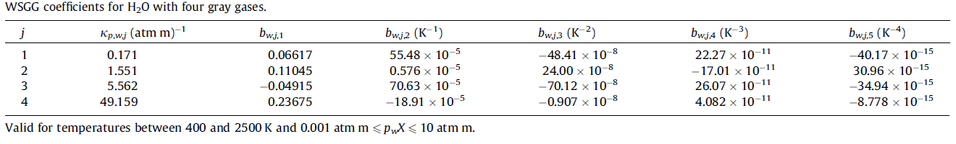

$CO_{2}$, 4 gray gases

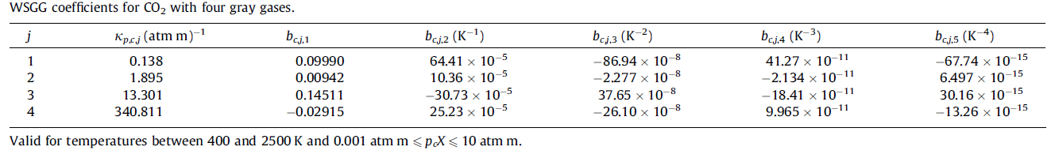

Soot , 2 gray gases

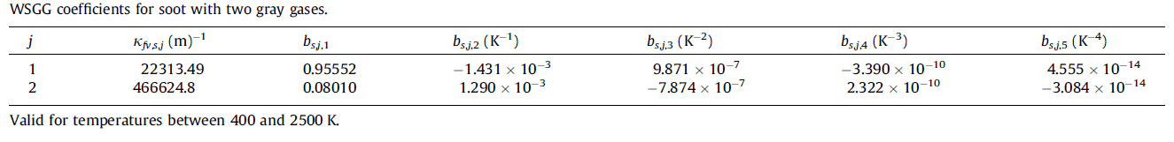

Soot , 4 gray gases

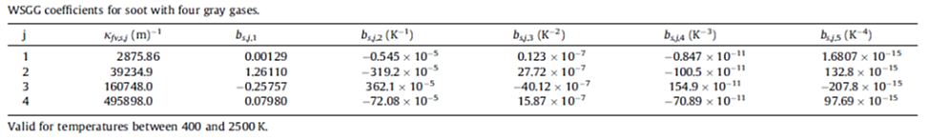

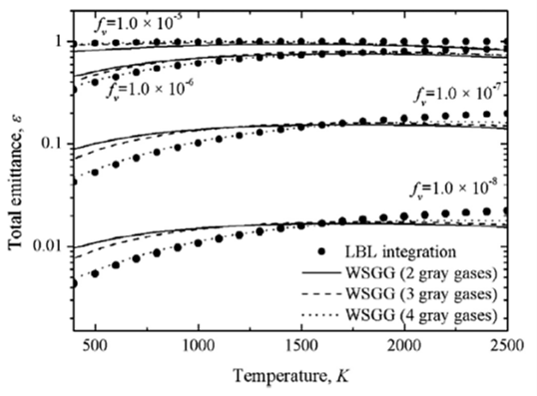

Fig. 1 Total emittance of soot computed by LBL and WSGG with different number of gray gases (Results of Cassol et al. IJHMT 2014)

**Appendix B**

$\frac{p_{w}}{p_{c}}=2$, 4 gray gases

